

Low Level Design (LLD)

Heart Disease Diagnostic Analysis

Revision Number: 1.0

Last date of revision: 19/10/2022

SOURAV DEY

Document Control

|  |  |  |  |
| --- | --- | --- | --- |
| Date | Version | Description | Author |
| 19/10/2022 | 1.0 | FIRST VERSION OF COMPLETE (LLD) | SOURAV DEY |
|  |  |  |  |
|  |  |  |  |

**Contents**

Document Version Control

1.Introduction

1.1What is Low Level Design Document?

1.2 Scope

1.3 Project Introduction

2. Problem Statement

3. Dataset Information

4. Architecture

4.1 Architecture Description

1. Introduction

**1.1 What is Low Level Design Document?**

The goal of the Low-level design document (LLDD) is to give the internal logic design of the actual program code for the Heart Disease Diagnostic Analysis dashboard. LLDD describes the class diagrams with the methods and relations between classes and programs specs. It describes the modules so that the programmer can directly code the program from the document.

**1.2 What is Scope?**

Low-level design (LLD) is a component-level design process that follows a stepby-step refinement process. The process can be used for designing data structures, required software architecture, source code and ultimately, performance algorithms. Overall, the data organization may be defined during requirement analysis and then refined during data design work.

**1.3 Project Introduction**

Heart disease is a term covering any disorder of the heart. Heart diseases have become a major concern to deal with as studies show that the number of deaths due to heart diseases have increased significantly over the past few decades in India it has become the leading cause of death in India. A study shows that from 1990 to 2016 the death rate due to heart diseases have increased around 34% from 155.7 to 209.1 deaths per 1 lakh population in India. Thus, preventing heart diseases has become more than necessary. Good data-driven systems for predicting heart diseases can improve the entire research and prevention process, making sure that more people can live healthy lives.

**2. Problem Statement**

Health is real wealth in the pandemic time we all realized the brute effects of covid-19 on all irrespective of any status. You are required to analyse this health and medical data for better future preparation. A dataset is formed by taking into consideration some of the information of 303 individuals.

**3. Dataset Information**

**age:** The person's age in years

**sex:** The person's sex (1 = male, 0 = female)

**cp:** The chest pain experienced (Value 1: typical angina, Value 2: atypical angina, Value 3: non-anginal pain, Value 4: asymptomatic)

**trestbps:** The person's resting blood pressure (mm Hg on admission to the hospital)

**chol:** The person's cholesterol measurement in mg/dl

**fbs:** The person's fasting blood sugar (> 120 mg/dl, 1 = true; 0 = false)

**restecg:** Resting electrocardiographic measurement (0 = normal, 1 = having ST-T wave abnormality, 2 = showing probable or definite left ventricular hypertrophy by Estes' criteria)

**thalach:** The person's maximum heart rate achieved

**exang:** Exercise induced angina (1 = yes; 0 = no)

**oldpeak**: ST depression induced by exercise relative to rest

**slope:** the slope of the peak exercise ST segment (Value 1: upsloping, Value 2: flat, Value 3: downsloping)

**ca:** The number of major vessels (0-3) thal: A blood disorder called thalassemia (3 = normal; 6 = fixed defect; 7 = reversable defect)

**num:** Heart disease (0 = no, 1 = yes)

4. Architecture

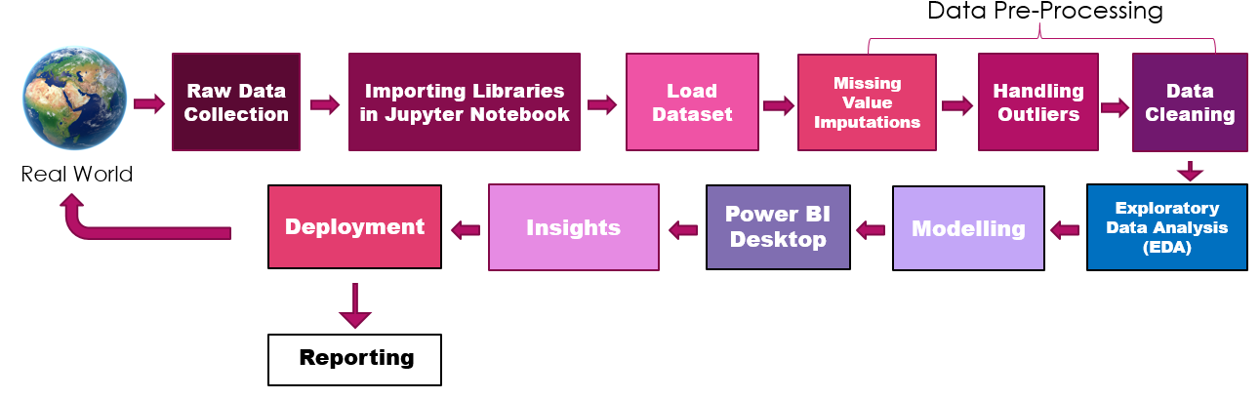

4.1 Architecture Description

**1. Raw Data Collection**

The Dataset was taken from iNeuron’s Provided Project Description Document

<https://drive.google.com/drive/folders/165Pjmfb9W9PGy0rZjHEA22LW0Lt3Y-Q8>

**2. Data Pre-Processing**

Before building any model, it is crucial to perform data pre-processing to feed the correct data to the model to learn and predict. Model performance depends on the quality of data feeded to the model to train. This Process includes

a) Handling Null/Missing Values

b) Handling Skewed Data

c) Outliers Detection and Removal

**3. Data Cleaning**

Data cleaning is the process of fixing or removing incorrect, corrupted, incorrectly formatted, duplicate, or incomplete data within a dataset.

a) Remove duplicate or irrelevant observations

b) Filter unwanted outliers

c) Renaming required attributes

**4. Exploratory Data Analysis (EDA)**

Exploratory Data Analysis refers to the critical process of performing initial investigations on data to discover patterns, spot anomalies, test hypothesis and to check assumptions with the help of summary statistics and graphical representations.

**5. Reporting**

Reporting is a most important and underrated skill of a data analytics field. Because being a Data Analyst you should be good in easy and self explanatory report because your model will be used by many stakeholders who are not from technical background. a) High Level Design Document (HLD) b) Low Level Design Document (LLD) c) Architecture d) Wireframe e) Detailed Project Report f) Power Point Presentation.

**6. Modelling**

Data Modelling is the process of analysing the data objects and their relationship to the other objects. It is used to analyse the data requirements that are required for the business processes. The data models are created for the data to be stored in a database. The Data Model's main focus is on what data is needed and how we have to organize data rather than what operations we have to perform.

**7. Deployment**

We created a Power BI Dashboard.

